

**(Established under the Presidency University Act, 2013 of the Karnataka Act 41 of 2013)**

**Course Code : CSE1006 Course Title : Problem solving using java**

**Multidimensional arrays:**

A multidimensional array can be defined as an array of arrays. Multidimensional array in Java represents 2D, 3D, ... arrays which is a combination of several type of arrays.

For example, a two-dimensional array is a combination of two or more one-dimensional (1D) arrays.

Each row is independently heap allocated, making it possible to have arrays with different row sizes.

**Note:** Multidimensional arrays in Java are not stored in tabular form.

Syntax for Multi-Dimensional Array :

data_type[1st dimension][2nd dimension][]..[Nth dimension] array_name = new

data_type[size1][size2]….[sizeN];

**Examples:**

// Two dimensional array:

int[][] twoD_arr = new int[3][4];

// Three dimensional array:

int[][][] threeD_arr = new int[4][5][6];

**Example of accessing multi dimensional arrays using for each loop:**

int[][] myNumbers = { {1, 2, 3, 4}, {5, 6, 7,8} }; // initialization of array

for (int[] row : myNumbers) {

for (int i : row) {

System.out.println(i);

}

}

1. A student visits the University library and in the month of June, July, and August he read fiction and non-fiction books, and magazines, both in paper copies (physical) and online (digital). You want to keep track of how many different types of books and magazines he read, and store that information in matrices. Here is the information below:

|  |  |  |
| --- | --- | --- |
| **July** | | |
|  | **PAPER** | **ONLINE** |
| **Fiction** | 3 | 2 |
| **Non-fiction** | 1 | 1 |
| **Magazines** | 5 | 3 |

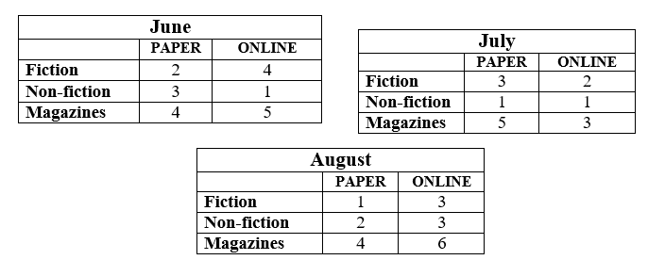

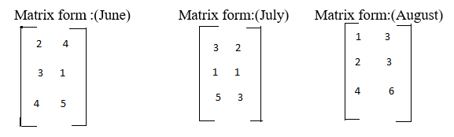

import java.util.Scanner;

class AddMatrix1

{

public static void main(String args[])

{

int m, n, i, j;

Scanner in = new Scanner(System.in);

System.out.println("Enter the number of rows and columns of matrix");

m = in.nextInt();

n = in.nextInt();

int first[][] = new int[m][n];

int second[][] = new int[m][n];

int third[][]=new int[m][n];

int sum[][] = new int[m][n];

System.out.println("Enter the books which the student read in the month of June and it's matrix form is");

for (i = 0; i < m; i++)

for (j = 0; j < n; j++)

first[i][j] = in.nextInt();

System.out.println("Enter the books which the student read in the month of July and it's matrix form is");

for (i = 0; i < m; i++)

for (j = 0; j < n; j++)

second[i][j] = in.nextInt();

System.out.println("Enter the books which the student read in the month of August and it's matrix form is");

for (i = 0; i < m; i++)

for (j = 0; j < n; j++)

third[i][j] = in.nextInt();

//Sum of matrices is:

for (i = 0; i < m; i++)

for (j = 0; j < n; j++)

sum[i][j] = first[i][j] + second[i][j]+third[i][j];

System.out.println("Total number of different types of books and magazines student read is : In matrix form");

for (i = 0; i < m; i++)

{

for (j = 0; j < n; j++)

System.out.print(sum[i][j]+"\t");

System.out.println();

}

}

}

===================================

1. Two softball teams submit equipment lists to their sponsors. The equipment lists for Team A and Team B are as follows:

|  |  |  |  |
| --- | --- | --- | --- |
| **Teams** | **Balls** | **Bats** | **Gloves** |
| **Team -A** | 12 | 45 | 15 |
| **Team -B** | 15 | 38 | 17 |

|  |  |
| --- | --- |
| **Equipment Name** | **Cost** |
| **Balls** | 9$ |
| **Bats** | 80$ |
| **Gloves** | 60$ |

Find the total cost of the equipment for each team.

import java.util.Scanner;

class MatrixMul

{

public static void main(String args[])

{

int m, n, p, q, c, d, k;

Scanner in = new Scanner(System.in);

System.out.println("Enter the number of rows and columns of first matrix");

m = in.nextInt();

n = in.nextInt();

System.out.println("Enter the number of rows and columns of second matrix");

p = in.nextInt();

q = in.nextInt();

if (n != p)

{

System.out.println("The matrices can't be multiplied with each other.");

System.exit(0);

}

// otherwise continue the code

int first[][] = new int[m][n];

System.out.println("Enter the equipment lists for Team-A");

for (c= 0; c < m; c++)

for (d = 0; d < n; d++)

first[c][d] = in.nextInt();

int second[][] = new int[p][q];

int multiply[][] = new int[m][q];

System.out.println("Enter the equipment lists for Team-B");

for (c = 0; c < p; c++)

for (d = 0; d < q; d++)

second[c][d] = in.nextInt();

// multiplication of two matrices

for (c = 0; c < m; c++)

{

for (d = 0; d < q; d++)

{

multiply[c][d]=0;

for (k = 0; k < p; k++)

{

multiply[c][d] = multiply[c][d] + first[c][k]*second[k][d];

}

}

}

System.out.println("The total cost of the equipment for Team-A and Team-B are:");

for (c = 0; c < m; c++)

{

for (d = 0; d < q; d++)

System.out.print(multiply[c][d]+"\t");

System.out.print("\n");

}

}

}

=====================

Activity: Students can practice the problems related to matrices such as: trace of a matrix, row sum & column sum of a matrix.

=====================